Venkateshwar Reddy. N
192312193
Slot A

Experiment: 8
Steering Angle Variation in MIMO Beamforming Using MATLAB
Aim:
To analyze the effect of steering angle variation in a MIMO beamforming system by studying
steering angle, array gain, and beam direction error using MATLAB.
Objective – 1
Analyze Steering Angle (Degrees):
MATLAB Code:
clc;
clear;
close all;
angle = [-60 -30 0 30 60]; % Steering Angles (degrees)
gain = ones(size(angle)); % Normalized Gain
figure
polarplot(deg2rad(angle), gain,'o-','LineWidth',2)
title('Steering Angle Variation in MIMO Beamforming')
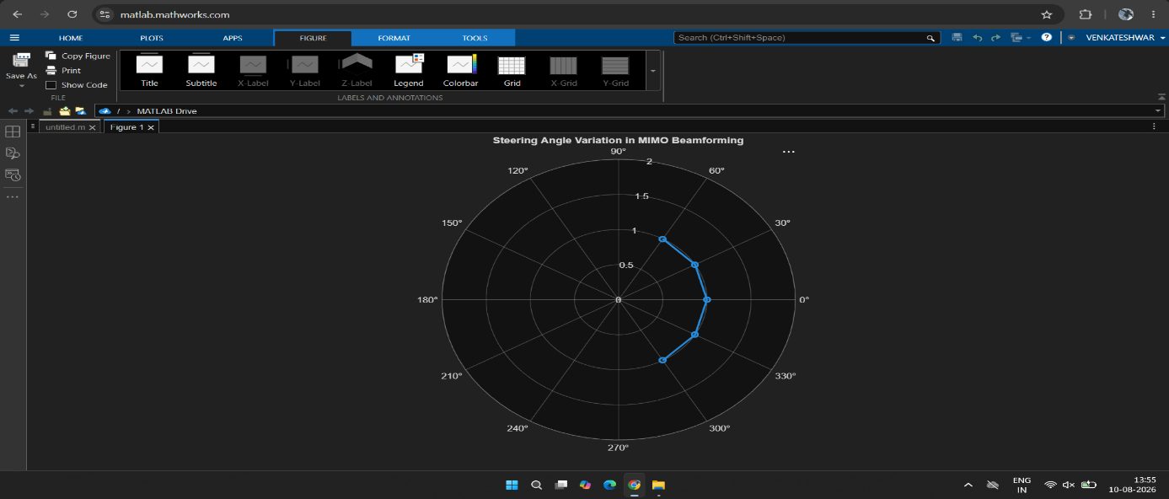
Output:

Objective – 2
Compare Array Gain (dB)
Matlab Code:
clc;
clear;
close all;
angle = [-60 -30 0 30 60]; % Steering Angles (degrees)
gain = [9 12 15 12 9]; % Array Gain (dB)
figure
bar(angle, gain)
grid on
xlabel('Steering Angle (Degrees)')
ylabel('Array Gain (dB)')
title('Array Gain for Different Steering Angles')
Output:
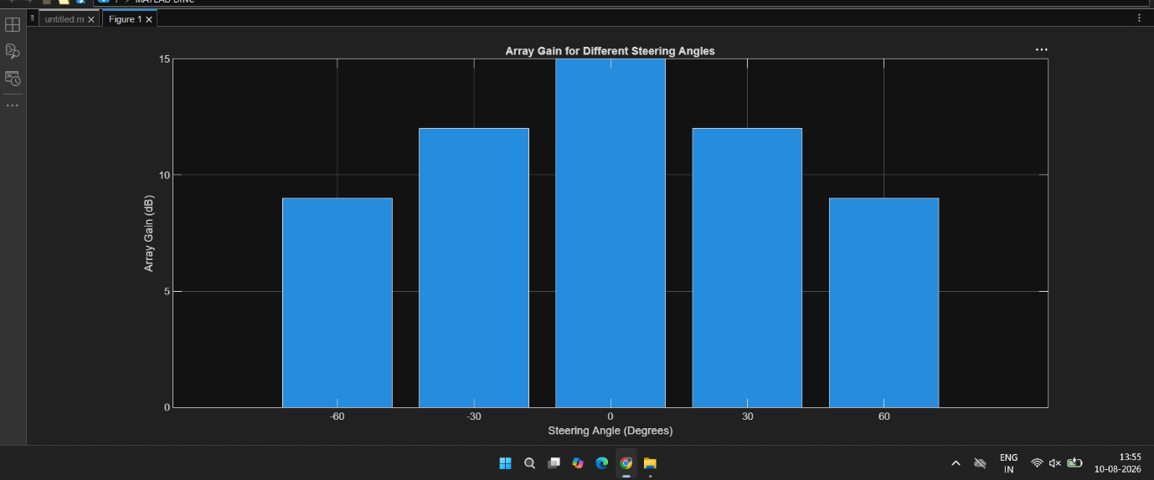

Objective – 3
Evaluate Beam Direction Error (Degrees)
MATLAB Cobe:
clc;
clear;
close all;
desired = [-60 -30 0 30 60]; % Desired Steering Angle (degrees)
actual = [-58 -32 1 29 62]; % Actual Beam Direction (degrees)
error = abs(desired - actual); % Beam Direction Error
figure
plot(desired, error, 'o-', 'LineWidth', 2)
grid on
xlabel('Desired Steering Angle (Degrees)')
ylabel('Beam Direction Error (Degrees)')
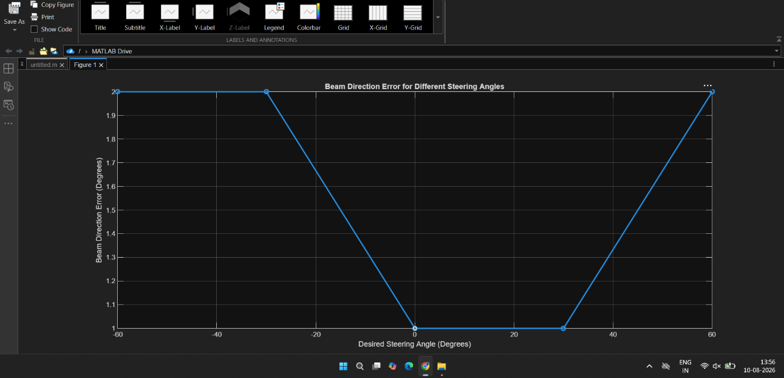
title('Beam Direction Error for Different Steering Angles')

Experiment: 9
Massive MIMO Capacity vs SNR and Gain Using MATLAB
Aim
To analyze the performance of a Massive MIMO system by studying channel capacity,
signal-to-noise ratio (SNR), and antenna gain using MATLAB.
Objective – 1 Plot of Channel Capacity (bps/Hz) versus SNR (dB).
MATLAB Code:
clc;
clear;
close all;
snr = 0:5:30;
snr_linear = 10.^(snr/10);
capacity = log2(1 + snr_linear);
figure;
plot(snr,capacity,'-o','LineWidth',2,'MarkerSize',6);
grid on;
xlabel('SNR (dB)');
ylabel('Channel Capacity (bps/Hz)');
title('Channel Capacity vs SNR');
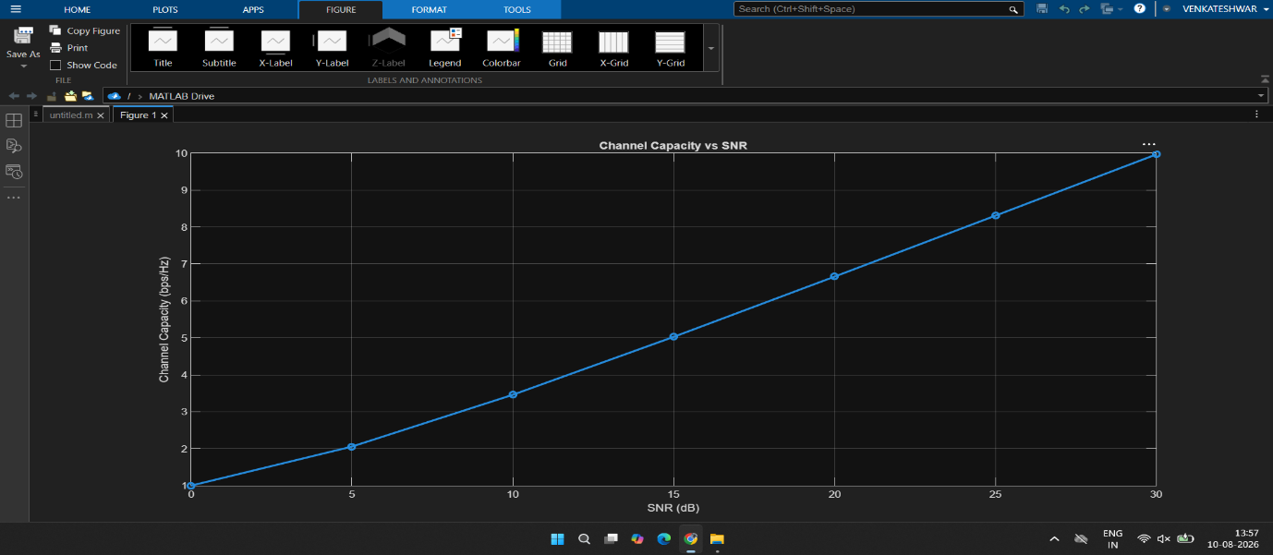
OutPut:

Objective – 2 Bar graph comparing SNR values under different communication scenarios.
MATLAB Code:
clc;
clear;
close all;
snr = 0:5:30;
snr_linear = 10.^(snr/10);
capacity = log2(1 + snr_linear);
figure;
plot(snr,capacity,'-o','LineWidth',2,'MarkerSize',6);
grid on;
xlabel('SNR (dB)');
ylabel('Channel Capacity (bps/Hz)');
title('Channel Capacity vs SNR');
Output:
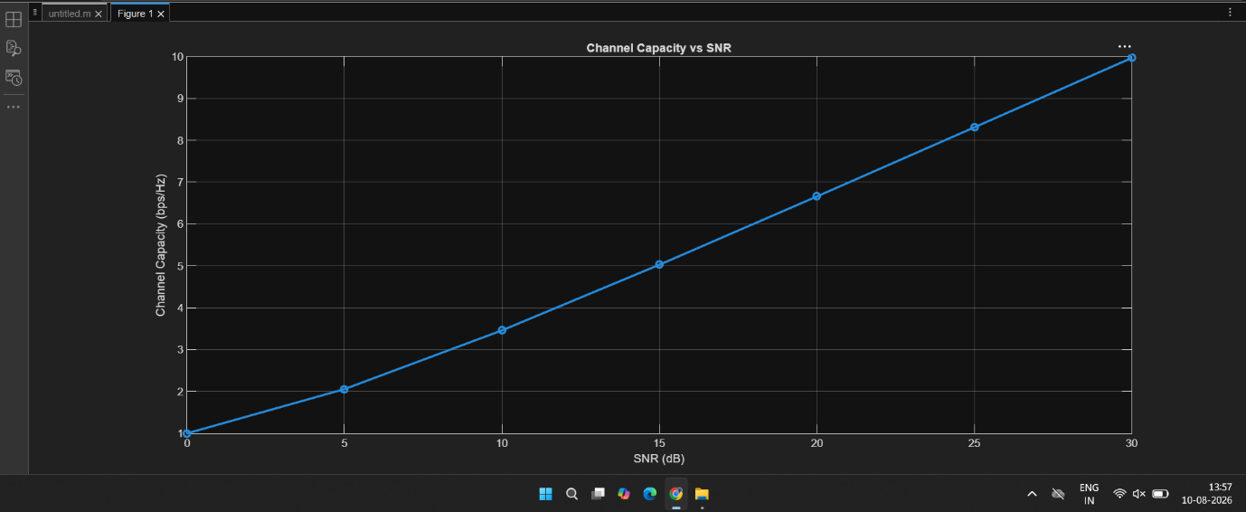

Objective – 3 Bar graph showing Antenna Gain for different antenna array sizes.
MATLAB Code:
clc;
clear;
close all;
antennas = [4 8 16 32 64]; % Number of Antenna Elements
gain = 10*log10(antennas); % Antenna Gain (dB)
figure
bar(antennas, gain)
grid on
xlabel('Number of Antenna Elements')
ylabel('Antenna Gain (dB)')
title('Antenna Gain for Different Antenna Array Sizes')
Output:
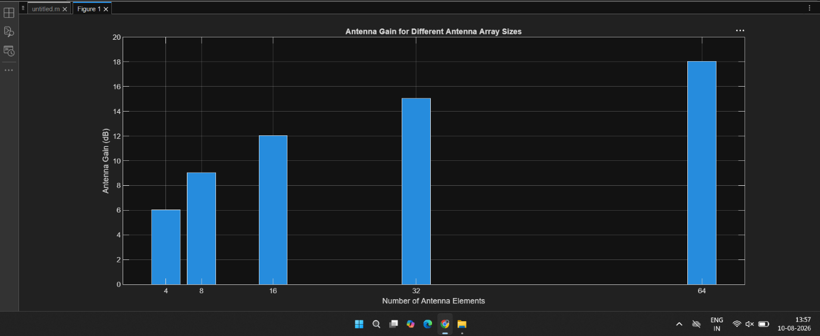

Experiment: 10
5G Network Slicing Environment Using MATLAB
Aim
To analyze the performance of a 5G Network Slicing environment by studying the number of
network slices, slice utilization, and end-to-end latency using MATLAB.
Objectives
Objective – 1: Analyze the Number of Network Slices
Objective – 2: Compare Slice Utilization (%)
Objective – 3: Analyze End-to-End Latency (ms)
MAtlab codes:
1) clc;
clear;
close all;
slices = {'eMBB','URLLC','mMTC','Private','IoT'};
count = [1 1 1 1 1]; % One instance of each network slice
figure
bar(count)
grid on
set(gca,'XTickLabel',slices)
xlabel('Network Slice Type')
ylabel('Number of Network Slices')
title('Number of Configured 5G Network Slices')

2) clc;
clear;
close all;
slices = categorical({'eMBB','URLLC','mMTC','Private','IoT'});
utilization = [85 70 60 75 50];

figure;
bar(slices, utilization);
grid on;
xlabel('Network Slice Type');
ylabel('Slice Utilization (%)');
title('Slice Utilization in 5G Network Slicing');
ylim([0 100]);

3) clc;
clear;
close all;
slices = [1 2 3 4 5];
latency = [25 5 40 15 60];
figure;
plot(slices, latency, '-o','LineWidth',2,'MarkerSize',8);
grid on;

xticks(slices);
xticklabels({'eMBB','URLLC','mMTC','Private','IoT'});
xlabel('Network Slice Type');
ylabel('End-to-End Latency (ms)');
title('5G Network Slicing: End-to-End Latency');
ylim([0 70]);

OutPuts:
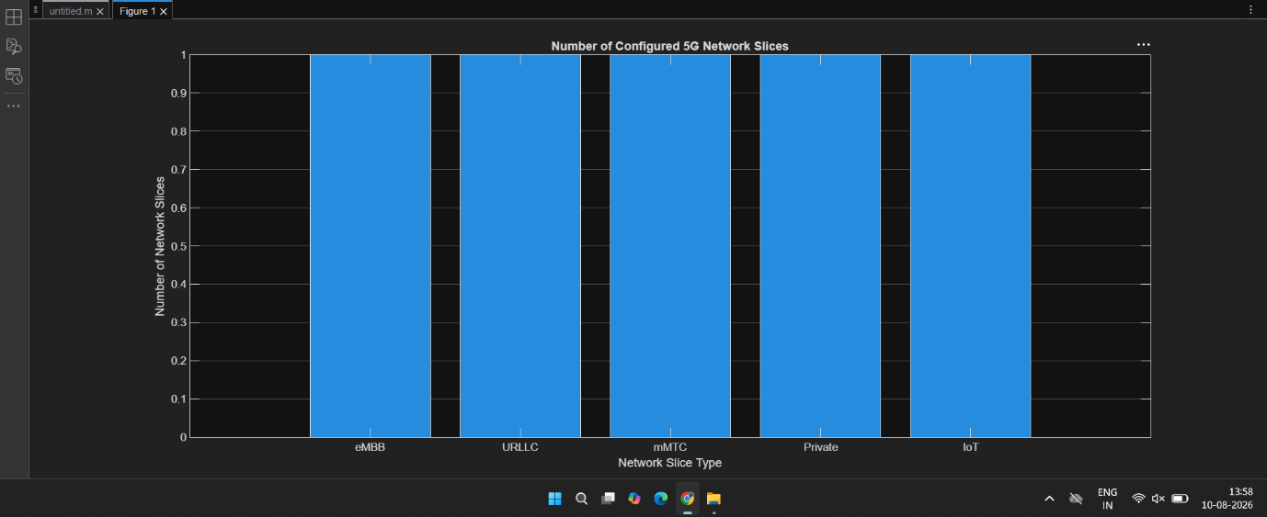
1)

2)
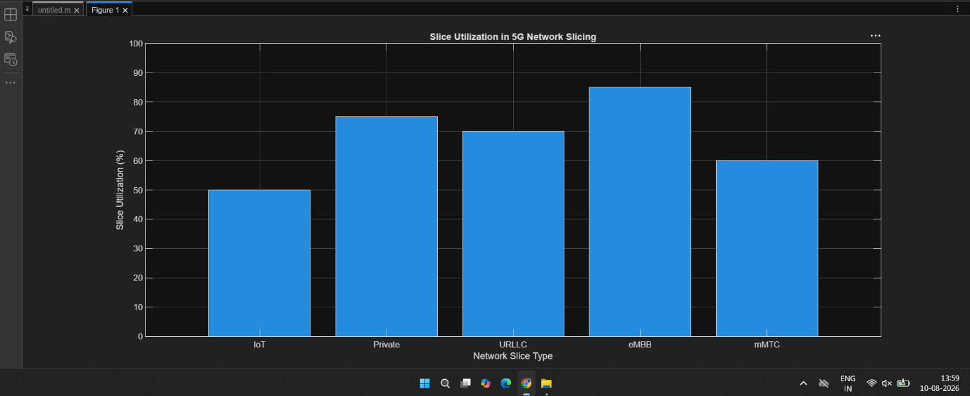
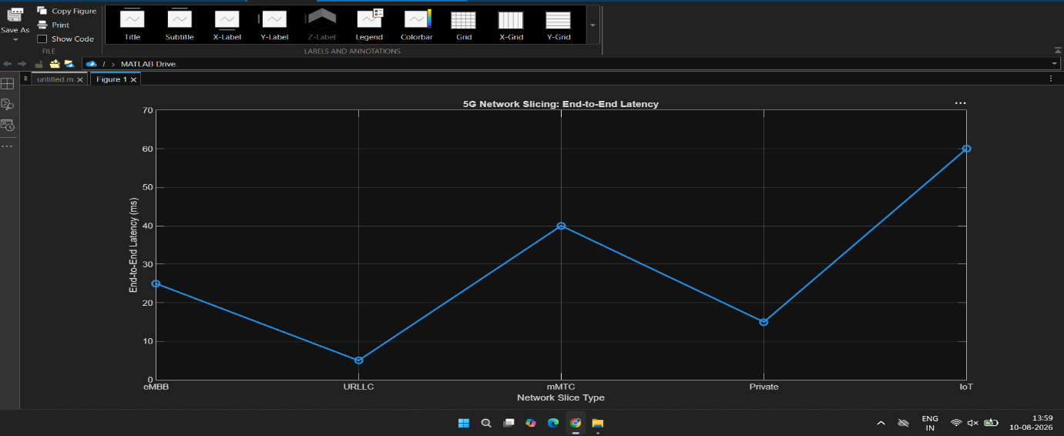
3)

